Computer Language Coding Concepts

Prime Event Example, Button Clicked
The key example that explains the purpose of events is a button click. A programmer defines the command to run when the user presses a button. The button click is implemented using the Events construct, so that a programmer can easily stick a procedure under a Button Clicked event without having to worry how the procedure really got invoked.

The notation of that is as follows.

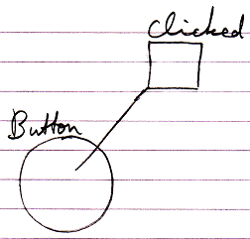

Author & Copyright: Jan-Joost van Zon Date: May 10, 2010 – May 14, 2010 Location: Oosterhout, The Netherlands Status: Finished

